Week 1: Wireshark Network Traffic analysis activity

Step 1: Setup and Launch(Kali Linux and Wireshark)
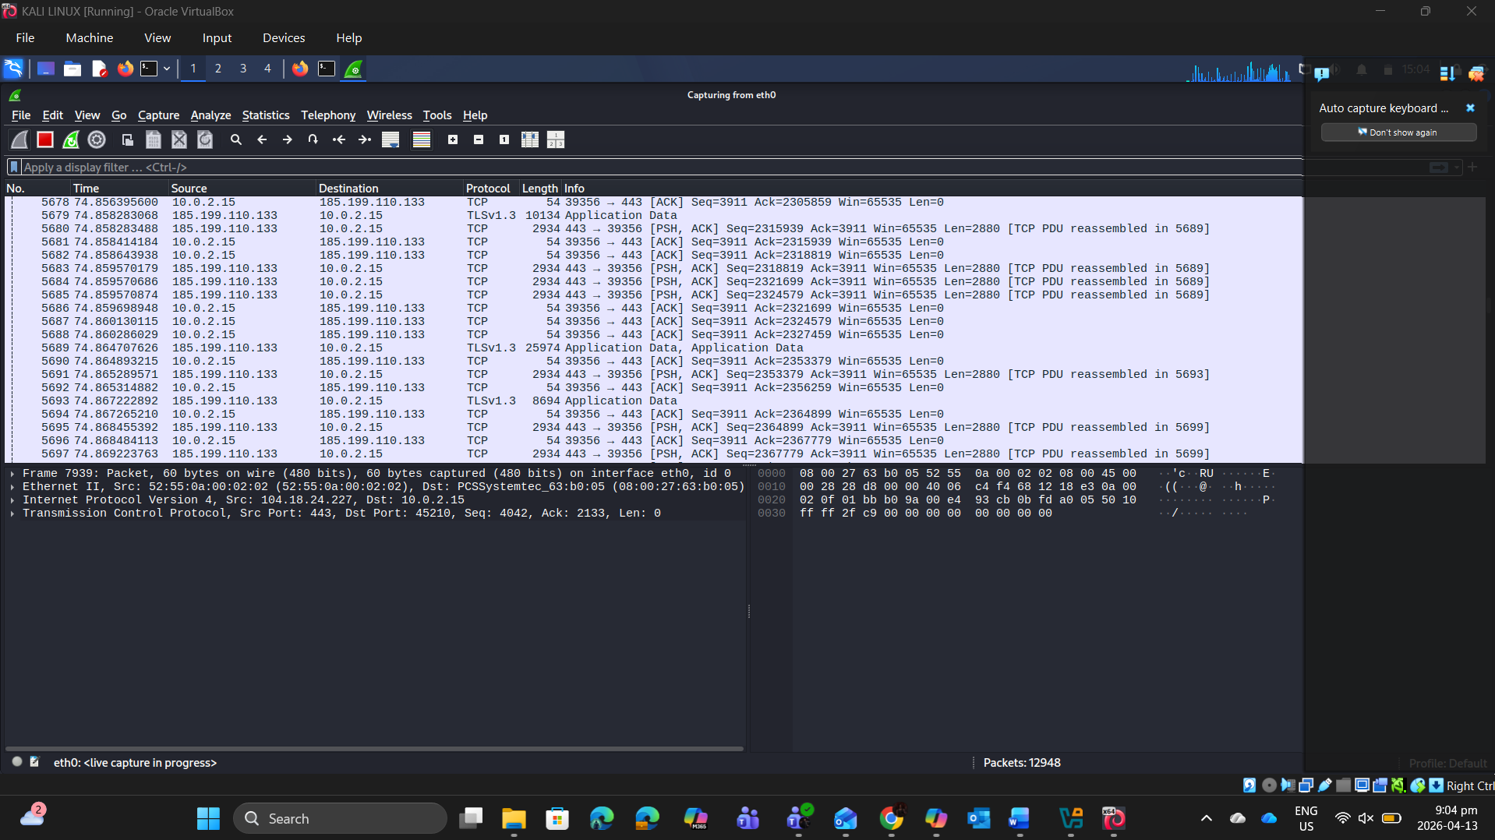
Wireshark interface showing active capture on eth0.

Step 2: Generating Traffic

Generating Website Traffic.

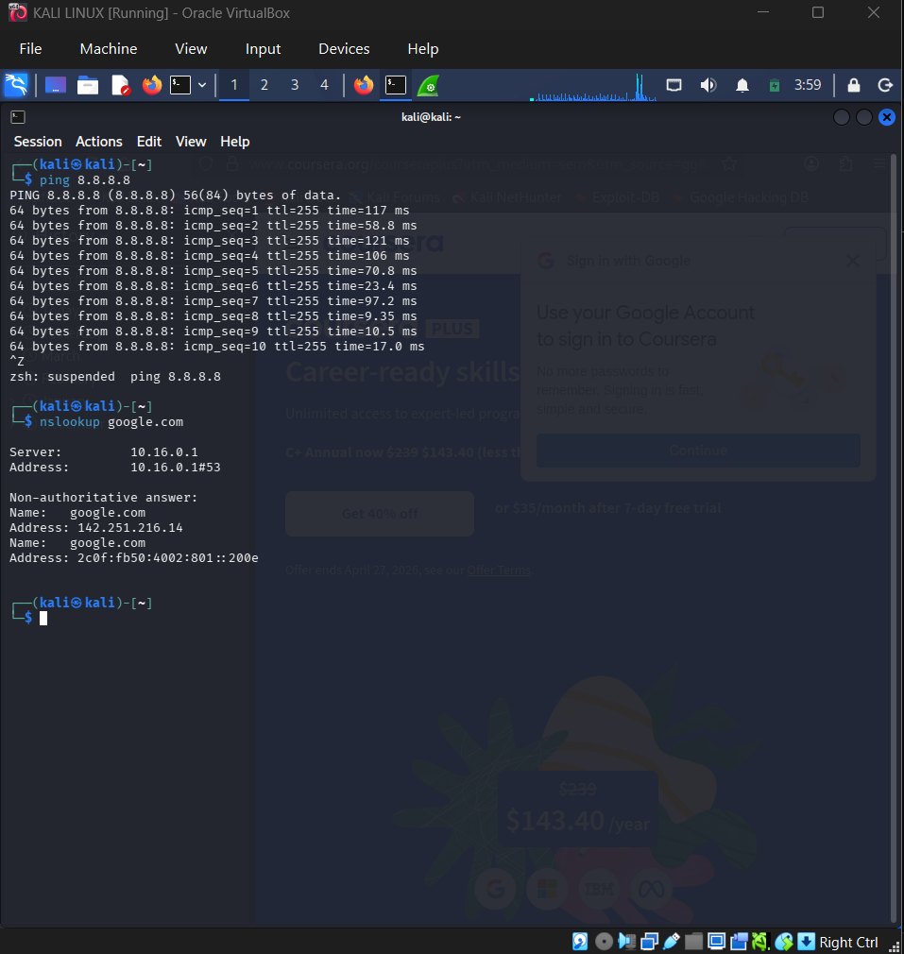
Terminal showing ping and nslookup commands of Course Era, Reddit and Udemy websites.

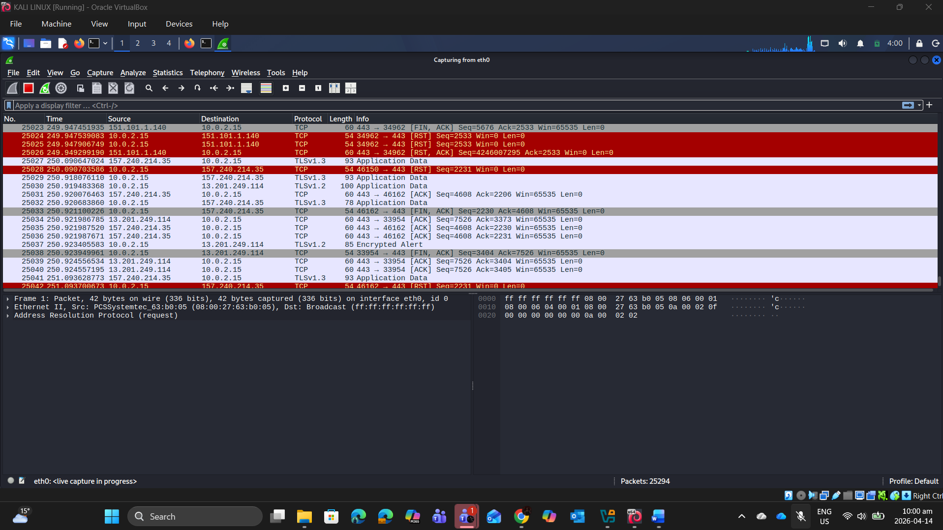
Wireshark successfully capturing the generated HTTP/HTTPS, ICMP, and DNS traffic in real time.

Step 3: Applying Display Filters using Wireshark
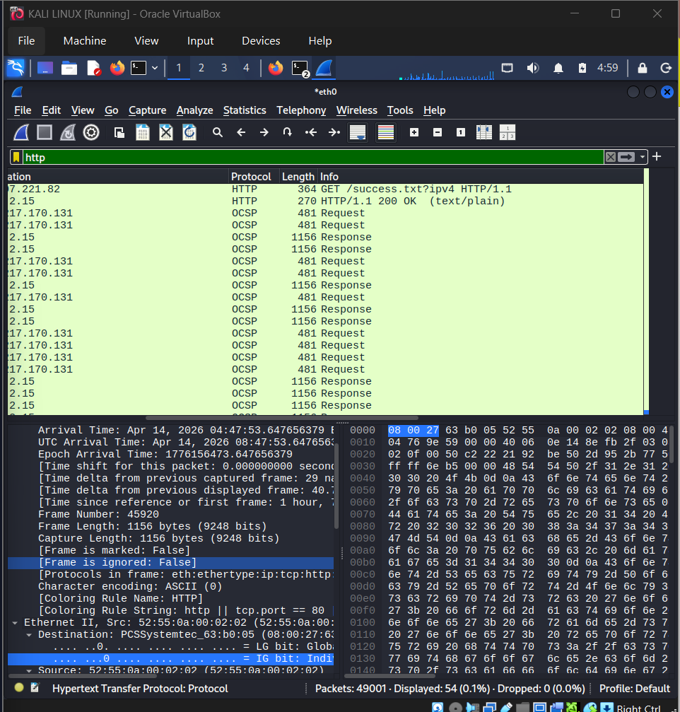
Http display filter applied

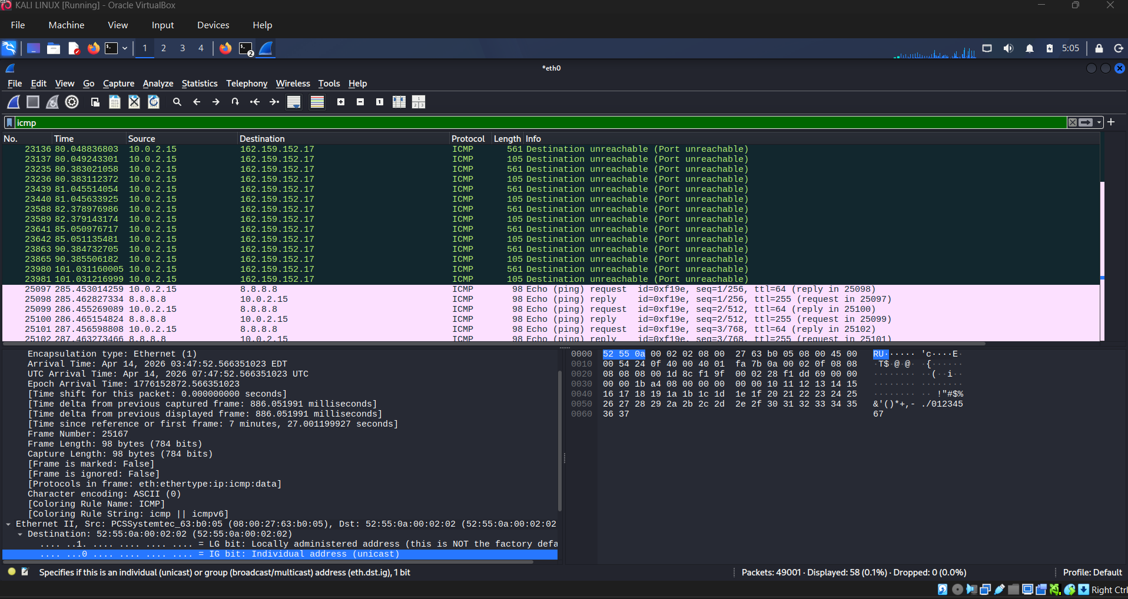
Icmp display filter applied

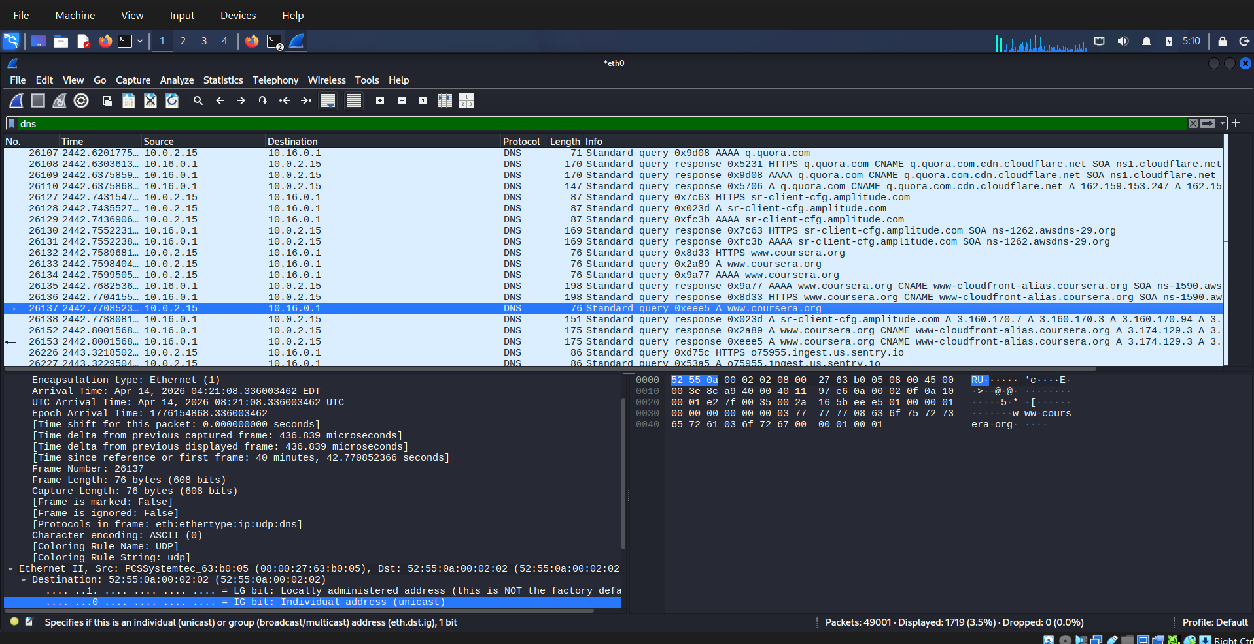
Dns filter applied. Course era and reddit is communicating with WireShark.

Step 4: Deep Packet Inspection

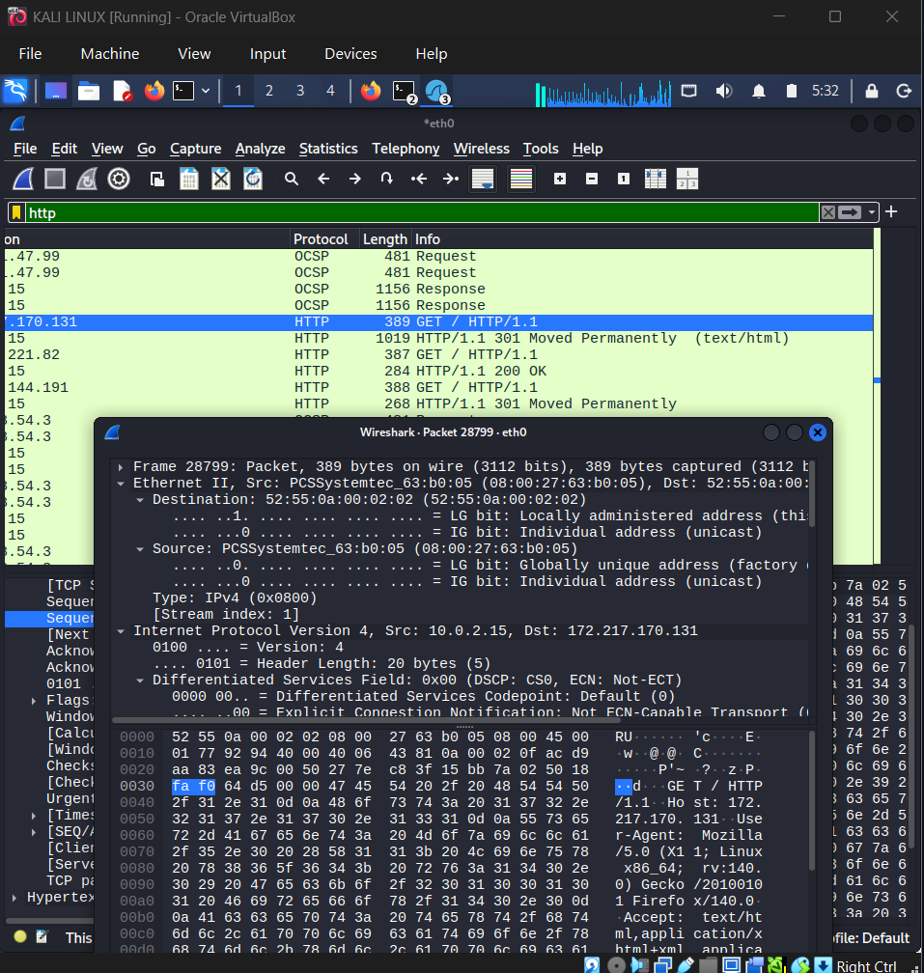
Deep packet inspection using Wireshark on HTTP Get request 389(CourseEra)

Step 5: Following a TCP Stream
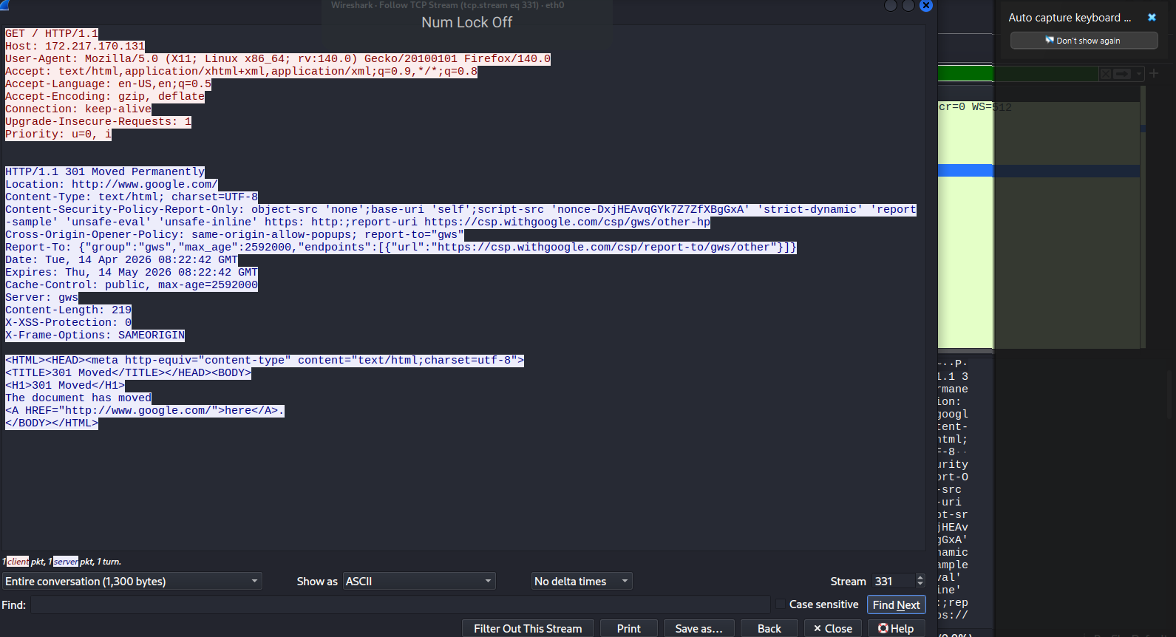
Following a TCP stream using a HTTP get request packet in Wireshark.

Findings:
Finding from Wireshark Packet | Detailed explanation
Client Request | A GET HTTP request is being sent to ip address 172.217.170.131
Server Response | Returned HTTP requests were moved permanently from google.
Key observation | Written in plaintext and its unencrypted data.
Recommended security controls to establish | Enforce HTTPS redirection, enable HSTS, and use TLS encryption for all traffic.

Step 6: Exporting, Hashing and Reporting
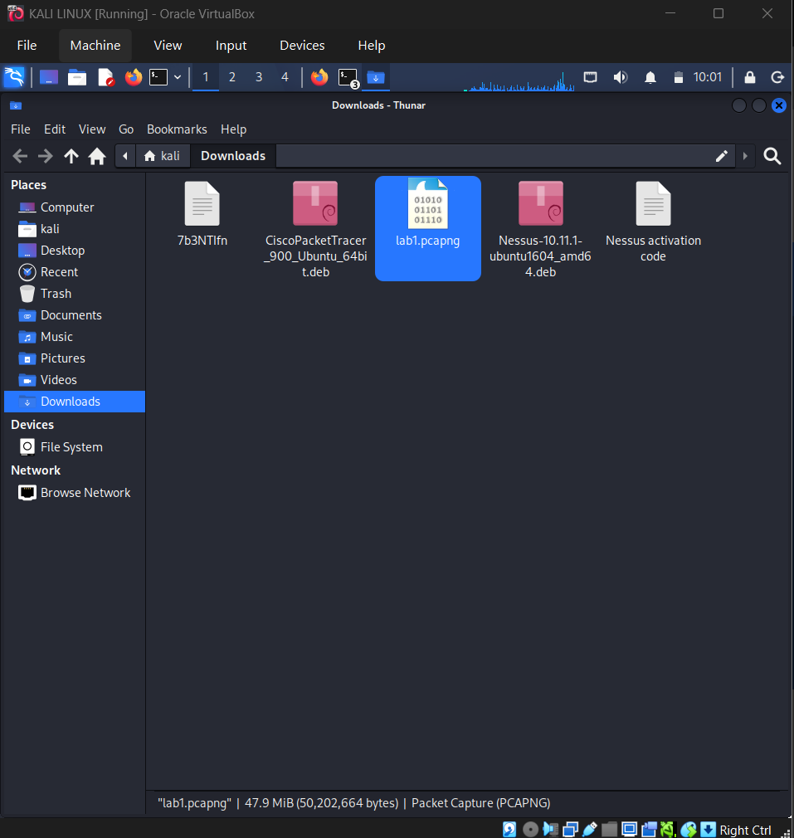
Saving the Wireshark file with captured packets in Kali Linux downloads.

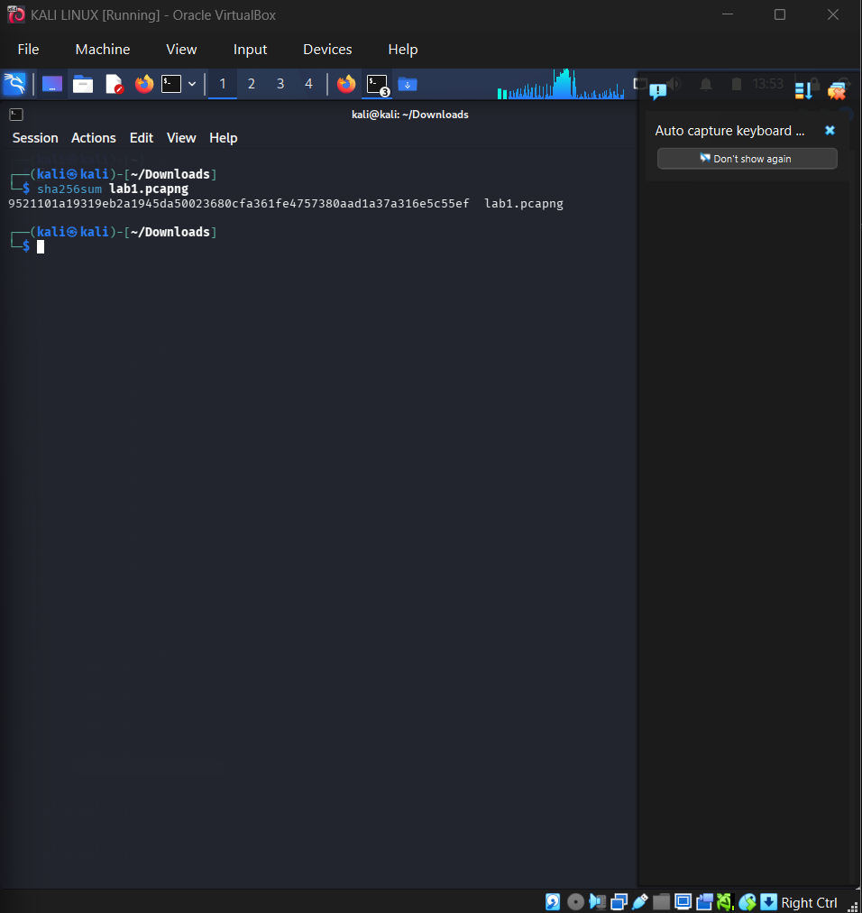
Recorded hash file

Lab Report: Network Capture Analysis (lab1.pcap)
I exported the lab1.pcpa wireshark file and hashed it using sha256sum to ensure that it has integrity. This report summarizes the findings from the packet analysis, highlighting the most common protocol observed, evidence of cleartext data, identified security risks, and recommended controls.

Findings:
Most common protocol utilized:
The majority of network traffic that I captured was HTTP and I made use of the http fileter in Wireshark to see if my 3 websites were communicating with each other. This means that HTTP is always unsecure and it transmits information using plaintext and it is not encrypted and secure.

Cleartext data identified:
Several packets contained unencrypted credentials and session information transmitted via HTTP. Examples included login forms and cookie values visible in packet payloads. This demonstrates the risk of sensitive data exposure when encryption is not enforced.

- Security Risks:
- Unencrypted Communication: HTTP traffic exposes credentials and session tokens to interception.
- Session Hijacking Potential: Visible cookies and tokens could allow attackers to impersonate users.
- Information Disclosure: Metadata such as hostnames, user agents, and internal IP addresses were transmitted openly, aiding reconnaissance efforts.

Recommended Controls:
Enforce HTTPS/TLS: All web traffic should be encrypted to protect credentials and session data.
-Implement Secure Authentication: Use strong password policies, multi‑factor authentication, and avoid transmitting credentials in plaintext.
Harden Network Monitoring: Deploy intrusion detection systems (IDS) to flag cleartext transmissions and unusual traffic patterns.

Conclusion:
The analysis of lab1.pcap highlights the risks of unencrypted communication and the ease with which sensitive information can be intercepted. By enforcing encryption, strengthening authentication, and monitoring traffic, organizations can significantly reduce exposure to these threats.

